MD.120 Release & Deployment

Transguard Group

Deployment Module Migration



Author: Abdulrahman Mohammed

Creation Date: 29-Jun-17

Last Updated: 29-Jun-17

Document Ref: V2

Version: 3.0

## Document Control

**Change Record**

***Note****: The version number consists of two distinct digits. The leading digit reflects the version to be considered by the users and this digit is only updated after review by Transguard HR.*

3

| **Date** | **Author** | **Version** | **Change Reference** |
| --- | --- | --- | --- |
|  |  |  |  |
| 27-Jun-17 | Abdulrahman | 1.0 | Draft |
| 29-Jun-17 | Abdulrahman | 2.0 | Added Sequence number to activities |
|  |  |  |  |
|  |  |  |  |

**Reviewers**

| **Name** | **Position** |
| --- | --- |
|  |  |
|  |  |
|  |  |
|  |  |

**Distribution**

Approved versions of this document have been distributed to the following:

| **Copy No.** | **Name** | **Location** |
| --- | --- | --- |
|  |  |  |
|  |  |  |
|  |  |  |
|  |  |  |

**Approvals**

Approved versions of this document have been distributed to the following:

| **Copy No.** | **Name** | **Location** |
| --- | --- | --- |
|  |  |  |
|  |  |  |
|  |  |  |

**Note to Holders:**

If you receive an electronic copy of this document and print it out, please write your name on the equivalent of the cover page, for document control purposes.

If you receive a hard copy of this document, please write your name on the front cover, for document control purposes.

Contents

Document Control 2

Preface 5

1. Introduction 6

2. Description 7

About Release 7

Application Server Name 7

Application Name 7

Build Number 7

Have you changed any setting on web Server? 7

Have You Applied changes on DB Server? 7

Have you check in all source code to SCCS? 7

Downtime date & time (if required)? 7

Have you communicated about this release? 8

Impact on modules due to this release? Please specify. 8

Any other Impact? 8

DB Scripts 8

3. Exceptions 15

4. Open and Closed Issues 16

5. Appendix A: 17

6. Security: 18

# Preface

# Introduction

The First Task is Deployment of jar files,

We have mentioned all the jar files for deployment, which has to be kept on $JAVA_TOP and we have to run command jar xf *.jar

After that DB All Scripts have to Executed in Sequence of Sequence Number

After this we have **Migration Of Workflow**

After this All LDT Files has to be executed in sequence

The AME Setup is functional tasks that has to be done by Functional Administrator

# Description

### About Release

### Application Server Name

UAT Instance

### Application Name

UAT

### Build Number

### Have you changed any setting on web Server?

### Have You Applied changes on DB Server?

### Have you check in all source code to SCCS?

### Downtime date & time (if required)?

29-Jun-17

### Have you communicated about this release?

### Impact on modules due to this release? Please specify.

No Impact on any modules

### Any other Impact?

### Sequence of Activities

#### Deployment of Jar files

**We have mentioned all the jar files for deployment in the request, which has to be kept on $JAVA_TOP and we have to run command**

**[appltguat@tghqorauat1 classes]$ jar xf log4j-1.2.16.jar**

**[appltguat@tghqorauat1 classes]$ jar xf ooxml-schemas-1.1.jar**

**[appltguat@tghqorauat1 classes]$ jar xf poi-3.7-beta1.jar**

**[appltguat@tghqorauat1 classes]$ jar xf poi-3.8.jar**

**[appltguat@tghqorauat1 classes]$ jar xf poi-ooxml-3.7.jar**

**[appltguat@tghqorauat1 classes]$ jar xf poi-ooxml-schemas-3.7.jar**

**[appltguat@tghqorauat1 classes]$ jar xf stax-api-1.0.1.jar**

**[appltguat@tghqorauat1 classes]$ jar xf xmlbeans-2.4.0.jar**

**Unzip oaft-v2.0.zip**

**Add to $JAVA_TOP/com/ from oaft-v2.0/com/\***

#### DB Scripts

**Please execute the following scripts in sequence**

**10_XXTG_CUSTOM_TAB_REG**

**11_REGISTER_TABLE_PROCEDURE**

**15_CREATE_REGISTER_TABLE_SCRIPT_V2**

**30_XXTG_CA_DEPLOYMENT_PKG**

**40_XXTG_AME_APPROVAL_PKG**

**50_XXTG_AME_START_APPR_PKG**

**60_XXTG_CA_GEN_PKG**

**65_XXTG_CONTRACT_AUDIT**

#### Migration of Workflow

**Copy the Workflow to $APPL_TOP/tgcust/12.0.0/patch/115/import/XXTGCA.wft**

**execute following in sqlplus**

**WFLOAD apps/$appspwd@TGUAT 0 Y FORCE $APPL_TOP/tgcust/12.0.0/patch/115/import/XXTGCA.wft**

#### Migration of OAF Code

**After Copying All the Files to TGCUST.zip to $JAVA_TOP/oracle/apps/tgcust**

**please change the directory to server in XXTGCA and run the following java script**

**javac *.java**

**please change the directory to webui in XXTGCA and run the following java script**

**javac *.java**

**please change the directory to server in CA and run the following java script**

**javac *.java**

**please change the directory to webui in CA and run the following java script**

**javac *.java**

**we have to run following in SQL to delete existing pages**

**DECLARE**

**BEGIN**

**jdr_utils.deletedocument(p_document => '/oracle/apps/tgcust/xxtgca/webui/CAQueryPG');**

**jdr_utils.deletedocument(p_document => '/oracle/apps/tgcust/xxtgca/webui/ImportxlsPG');**

**jdr_utils.deletedocument(p_document => '/oracle/apps/tgcust/ca/webui/ContractsSearchPG');**

**commit;**

**END;**

**to check existence of pages execute following command, it should return null;**

**DECLARE**

**BEGIN**

**jdr_utils.printDocument('/oracle/apps/tgcust/xxtgca/webui/ImportxlsPG',1000);**

**EXCEPTION**

**WHEN OTHERS THEN**

**DBMS_OUTPUT.PUT_LINE(SQLERRM);**

**END;**

**DECLARE**

**BEGIN**

**jdr_utils.printDocument('/oracle/apps/tgcust/xxtgca/webui/CAQueryPG',1000);**

**EXCEPTION**

**WHEN OTHERS THEN**

**DBMS_OUTPUT.PUT_LINE(SQLERRM);**

**END;**

**java oracle.jrad.tools.xml.importer.XMLImporter $JAVA_TOP/oracle/apps/tgcust/xxtgca/webui/CAQueryPG.xml -username apps -password $pass -dbconnection "(DESCRIPTION=(ADDRESS=(PROTOCOL=tcp)(HOST=tghqodb-scan.transguard.ae)(PORT=1521))(CONNECT_DATA=(SERVICE_NAME=PROD)))" -rootdir $JAVA_TOP**

**java oracle.jrad.tools.xml.importer.XMLImporter $JAVA_TOP/oracle/apps/tgcust/xxtgca/webui/ImportxlsPG.xml -username apps -password $pass -dbconnection "(DESCRIPTION=(ADDRESS=(PROTOCOL=tcp)(HOST=tghqodb-scan.transguard.ae)(PORT=1521))(CONNECT_DATA=(SERVICE_NAME =PROD)))" -rootdir $JAVA_TOP**

**java oracle.jrad.tools.xml.importer.XMLImporter $JAVA_TOP/oracle/apps/tgcust/xxtgca/webui/posLOVRN.xml -username apps -password $pass -dbconnection "(DESCRIPTION=(ADDRESS=(PROTOCOL=tcp)(HOST=tghqodb-scan.transguard.ae)(PORT=1521))(CONNECT_DATA=( SERVICE_NAME =PROD)))" -rootdir $JAVA_TOP**

**java oracle.jrad.tools.xml.importer.XMLImporter $JAVA_TOP/oracle/apps/tgcust/ca/webui/ContractsSearchPG.xml -username apps -password $pass -dbconnection "(DESCRIPTION=(ADDRESS=(PROTOCOL=tcp)(HOST=tghqodb-scan.transguard.ae)(PORT=1521))(CONNECT_DATA=( SERVICE_NAME =PROD)))" -rootdir $JAVA_TOP**

#### Migration of Setup

**Execute this from Application server by first copying the LDT.zip to $TGCUST_TOP/bin folder and unzip it and run the following commands, we need apps password for this**

**--0. Concurrent Program LDT**

**FNDLOAD apps/$appspwd 0 Y UPLOAD $FND_TOP/patch/115/import/afcpprog.lct 100_XXTG_VALIDATE_CP.ldt - WARNING=YES UPLOAD_MODE=REPLACE CUSTOM_MODE=FORCE**

**FNDLOAD apps/$appspwd 0 Y UPLOAD $FND_TOP/patch/115/import/afcpprog.lct 80_XXTG_CONTRACT_AUDIT_CP.ldt - WARNING=YES UPLOAD_MODE=REPLACE CUSTOM_MODE=FORCE**

**FNDLOAD apps/$appspwd O Y UPLOAD $FND_TOP/patch/115/import/afcpprog.lct 105_XXTG_DELETE_ORPHAN_CP.ldt**

**FNDLOAD apps/$appspwd O Y UPLOAD $XDO_TOP/patch/115/import/xdotmpl.lct 90_XXTG_CONTRACT_AUDIT_DD.ldt**

**FNDLOAD apps/$appspwd O Y UPLOAD $XDO_TOP/patch/115/import/xdotmpl.lct 70_XXTG_OAF_PRINT_DD_TEMPLATE.ldt**

**--9. Menu**

**$FND_TOP/bin/FNDLOAD apps/$CLIENT_APPS_PWD O Y UPLOAD $FND_TOP/patch/115/import/afsload.lct 190_XXTG_DEPLOYMENT_CREATOR_MENU.ldt**

**--10 Request Group**

**FNDLOAD apps/$appspwd O Y UPLOAD $FND_TOP/patch/115/import/afcpreqg.lct 200_REPORT_GROUP_NAME.ldt**

**FNDLOAD apps/$appspwd O Y UPLOAD $FND_TOP/patch/115/import/afcpreqg.lct 201_REPORT_GROUP_NAME.ldt**

**--11 Responsibility**

**## note that XX_PERSON_RESPY is the responsibility key**

**## Now to upload**

**FNDLOAD apps/$appspwd O Y UPLOAD $FND_TOP/patch/115/import/afscursp.lct 210_RESPONSIBILITY.ldt**

**FNDLOAD apps/$appspwd O Y UPLOAD $FND_TOP/patch/115/import/afscursp.lct 211_RESPONSIBILITY.ldt**

**--12 Message**

**FNDLOAD apps/$appspwd 0 Y UPLOAD $FND_TOP/patch/115/import/afmdmsg.lct 220_MESSAGE.ldt**

**--13 Profile**

**FNDLOAD apps/$appspwd O Y UPLOAD $FND_TOP/patch/115/import/afscprof.lct 230_PROFILES.ldt**

**--14 Lookup**

**FNDLOAD apps/apps O Y UPLOAD $FND_TOP/patch/115/import/aflvmlu.lct 240_PROFILE_XXTG_DEP_MOD_NO_APPROVER_LKP.ldt UPLOAD_MODE=REPLACE CUSTOM_MODE=FORCE**

#### Functional Setup of AME

**Execute Following Task by Functional Administrator with Access to Approval Management Engine Business Analyst and Approval Management Engine Administrator Responsibility**

**Please do setup from AME_SETUP_TRAIN.docx Verbatim from TRAIN Instance**

#### Setup by System Administrator

1. Create Security Profile in TGST HRMS Setup Manager Called “TG Aviation” as in the snapshot

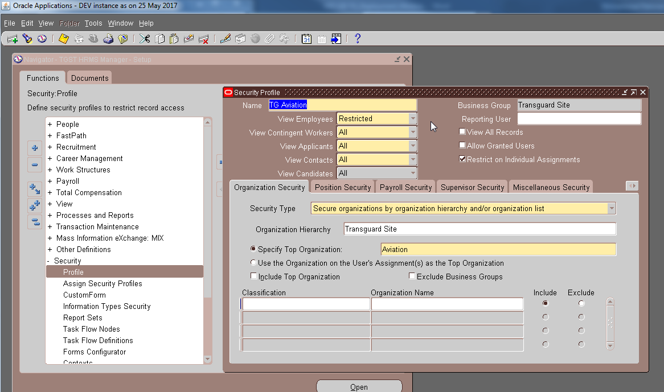

And Assign HR:Security Profile for Aviation Deployment and MOS Deployment Responsibility to “TG Aviation” and “Manpower and Outsource” Respectively

1. Run “Security List Maintenance” Program in TGST HRMS Setup Manager
2. Update Data Definition for XXTG_CONTRACT_PRINT to XXTG_CONTRACT_V3.xml
3. Update Layout for XXTG_CONTRACT_PRINT to XXTG_CONTRACT_V2.rtf
4. Update Data Definition for XXTG_CONTRACT_AUDIT to XXTG_CONTRACT_AUDIT_V4.xml
5. Update Layout for XXTG_CONTRACT_AUDIT to XXTG_CONTRACT_AUDIT_V1.rtf
6. Update Layout for XXTG_DRAFT_CONTRACT_PRINT to XXTG_CONTRACT_PRINT_OAF_V5.rtf

Setup by Functional Administrator

Copy the file oracle.zip to /ERP/PROD/Personalization and unzip it

Logon to Apps🡪 Responsibility Functional Administrator🡪 (Tab) Personalization 🡪 Export Personalization🡪 (Button) Import from file

Click and we should see the following page

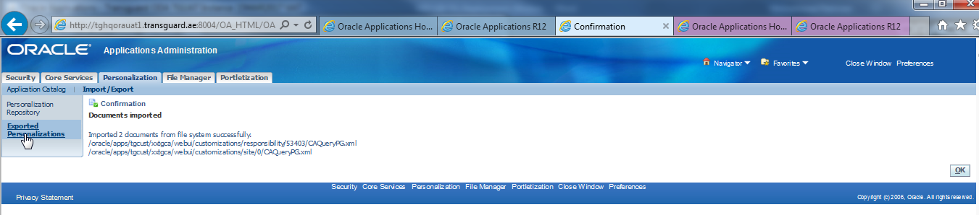

# Exceptions

# Open and Closed Issues

|  |  |  |  |  |
| --- | --- | --- | --- | --- |
| S.No | Issue | Decision | Date | Ownership |
| 1 |  |  |  |  |
| 2 |  |  |  |  |
| 3 |  |  |  |  |

# Appendix A:

# Security:

1. **Access Control Requirements:**

* Requiring a user identification and password to restrict system and data access.
* Developing applications that will not be overridden by SQL commands.
* Programming with valid accounts (ex: do not use anonymous or default accounts).
* Encrypt local passwords and follow the company password management policy.
* Integrate with Active directory using LAPS protocol.

1. **System and Data Integrity Concerns:**

* Perform software upgrades and security patches as per approvals.
* Restricted use of configuration files.
* Allow only acceptable error codes with proper handle.
* Data encryption for sensitive or critical data.
* Cookies holding sensitive information must be encrypted.

1. **Privacy/Confidentiality**

* Do not store sensitive information on web pages.
* Do not using persistent cookies (lifetime – undefined).
* Do not store personal information into cookies.

1. **Application security**

The developers must ensure that OWASP top 10 application security is addressed

* Injection
* Broken Authentication and Session Management
* Cross-Site Scripting (XSS)
* Broken Access Control (As it was in 2004)
* Web and Application Security Misconfiguration
* Sensitive Data Exposure
* Insufficient Attack Protection (NEW)
* Cross-Site Request Forgery (CSRF)
* Using Components with Known Vulnerabilities
* Under protected APIs (NEW)
* Hidden Field Manipulation

1. **Source code**

* Protect the source code with user identification and password
* Source Code definition must mention “meaningful information, eye readable, and unencrypted
* The codes written must be free from Viruses, Trojans, Bugs and other factors that may jeopardise its working, use of licensed software, testing and acceptance criteria, jurisdiction of Legal aspects.
* All codes should be submitted to TFS.

1. **Documentation**

* Techno functional Change Description.
* Deployment document.
* UAT Cases.

1. **Development Tools**

* Developer can use only below development tool to develop any application. In case of any new tool requirement development team must take approval from TG. Telerik, Obout, Twin Control, Visual Studio, Ajax Control, Fusion, Crystal Report, SQL Reporting, SQL Server, ORM, .NET Framework Version, PL-SQL Developer, SQL Developer, Data Loader, Oracle J Developer, Oracle Forms, Oracle Report, JVM /JDK.
* Application look and feel should be as per TG standard.